**Order Header Inquiry:** The Order Header Inquiry allows you to look up information on the current statuses of your orders after you have submitted them to CNH.

***TIP-Order Migration from GPS to CSPS*:** Unfilled Orders in GPS at launch will be migrated to CSPS.  They will have a new CSPS order number that does not relate to the GPS PSO number.   The CSPS customer order number will be the same as the GPS customer order number field (what the dealer/dms entered in the original GPS order)

* If a dealer has a duplicate customer order number, CSPS will append a sequential number (this should not happen as all customer order numbers listed under the same dealer are unique from each other).
* If the GPS order has a blank customer order number, CSPS will create an automatic customer order number with more than 8 characters (this should not happen as the customer order number should be filled).

***TIP-Orders Created in CSPS*:** If internal users create orders directly in CSPS on behalf of the dealer. and they do not manually add the customer order number, CSPS will create an automatic customer order number with more than 8 characters.

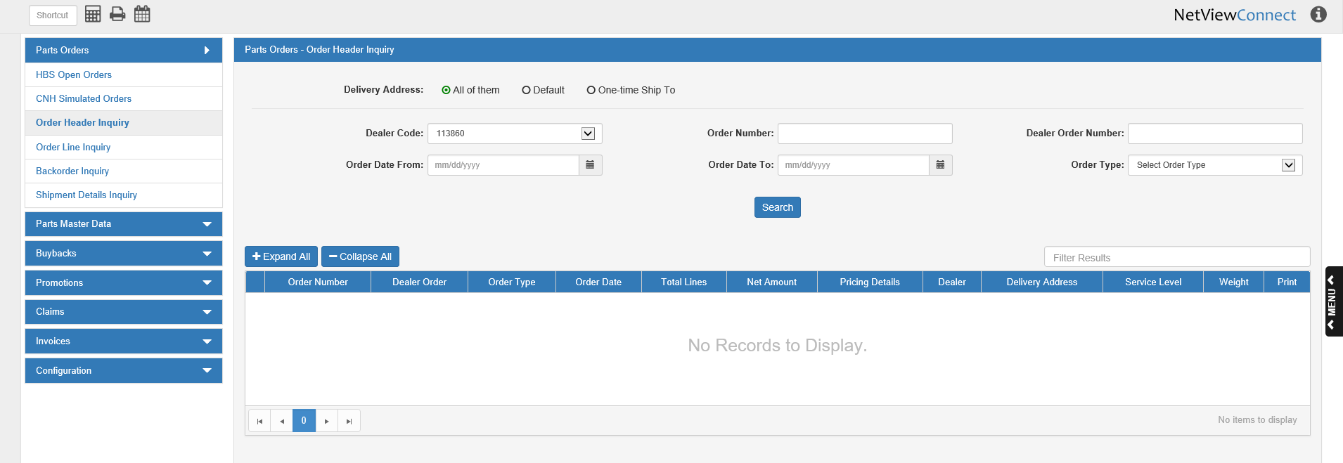

**Search Filter Fields:**

Delivery Address: Select what type of delivery address you want to search by:

* The dealer’s default address (Default)
* A one-time shipping address (One-time Ship To)
* All of them—**default selection**

Dealer Code: Set the dealer code to search by. This is mainly applicable for dealers who have more than one CNH code, and so may have attached different codes to different orders.

Order Number: To search by the CNH-assigned order number, enter the number here.

Dealer Order Number: To search by the dealer-assigned order number, enter the number here.

Order Date From/To: To search by a range of order dates, enter the starting and ending dates in these fields or select them from a calendar. To search for a single order date, enter the date in both fields.

Order Type: To search by the order type, select the type from the drop-down menu and then set a date range using the Order Date From/To fields. You are **required** to use the date filter along with the Order Type field by CNH. **NOTE:** In order for this filter to be available, you must load the Order Type list from CNH in the Order Types tab (see **Order Types** for more information).

**Search:** Click this button to start the search. The results will populate the grid below the search filters.

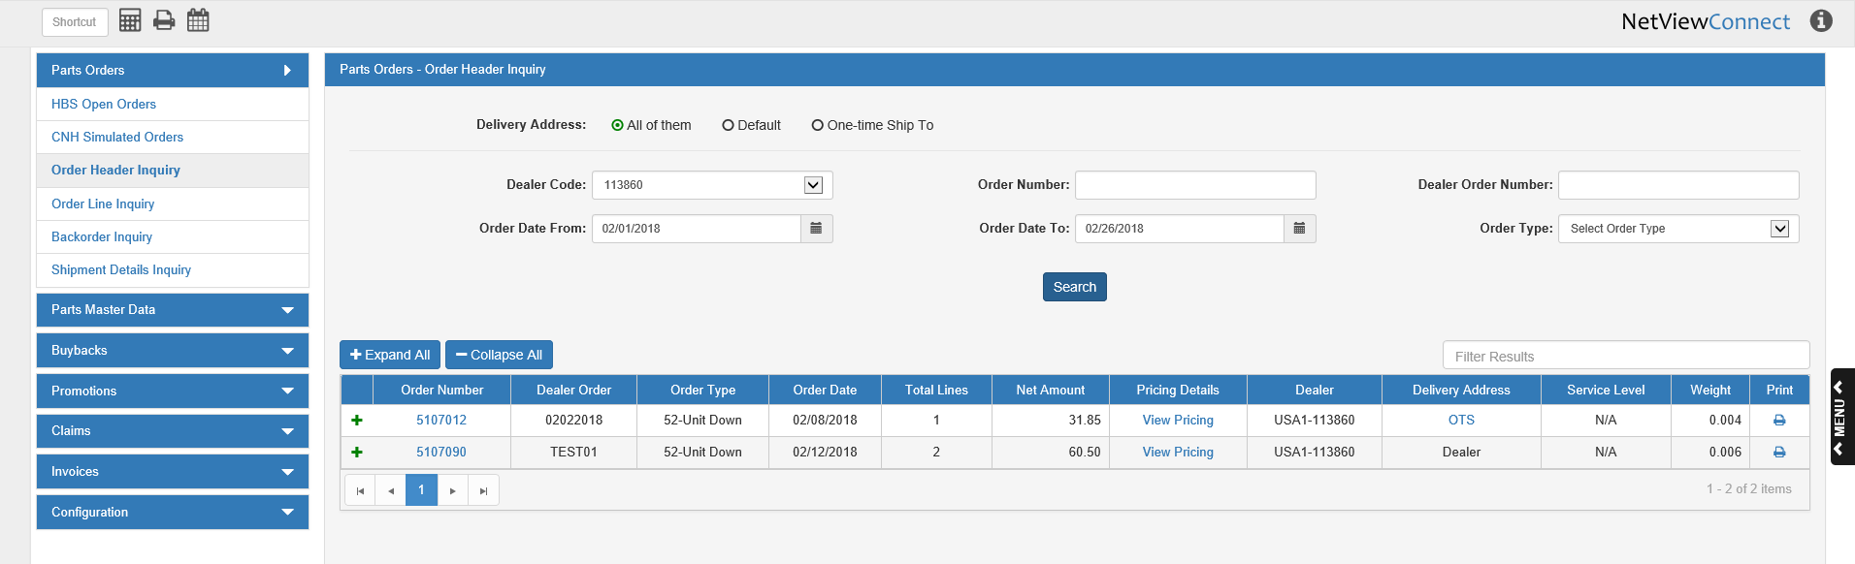

You can sort the results by the main grid column headers (but not the expanded column headers). Alternatively, you can filter the listing by entering specific information in the **Filter Results** field.

**Expand All/Collapse All:** Use these two buttons to expand or collapse all the lines displayed in the grid (see image below for an example of an expanded line). To expand or collapse an individual line, use the green + or – icon in the far-left column of the grid. **NOTE:** You cannot sort the grid by the normally hidden column headers (i.e. those revealed only when the line is expanded).

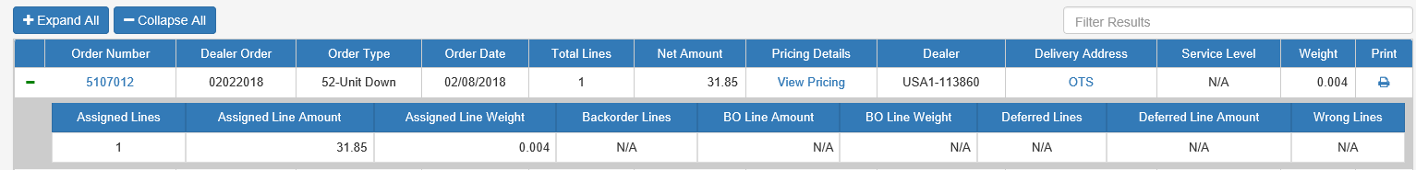

**Column Headers:**

Order Number: This column shows the CNH-assigned order number. Clicking on the number switches the screen to the **Order Line Inquiry** tab, which will automatically perform a search for that specific order number.

Dealer Order:

This column shows the dealer-assigned order number.

Order Type: This column shows the order type. If the type is **50-BDA**, then you can click on the type to view the BDA (Breakdown Assistance) details:

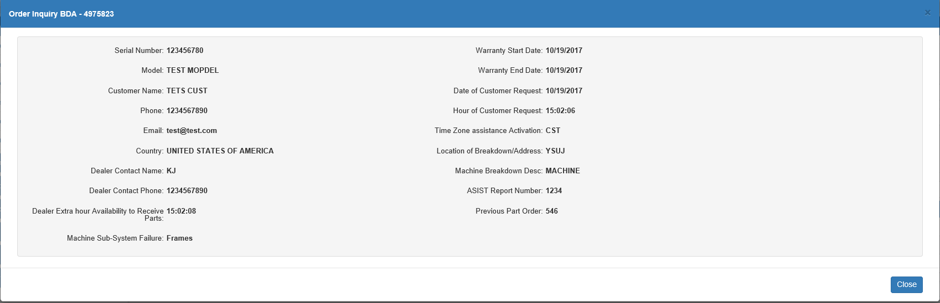

**Serial Number:** This field shows the serial number of the unit listed on the order (i.e. the unit that broke down).

**Model:** This field shows the unit’s model designation.

**Customer Name:** This field shows the name of the unit owner, i.e. the dealer’s customer.

**Phone:** This field shows the customer’s contact phone number.

**Email:** This field shows the customer’s contact email address.

**Country:** This field shows the customer/breakdown’s country of location.

**Dealer Contact Name:** This field shows the contact name at the dealership for this order.

**Dealer Contact Phone:** This field shows the dealer contact’s phone number.

**Dealer Extra hour Availability to Receive Parts:** This field shows a time period outside of the dealership’s normal business hours that they would be able to receive parts.

**Machine Sub-System Failure:** This field shows the machine sub-system failure classification for the breakdown.

**Warranty Start Date:** This field shows the warranty start date.

**Warranty End Date:** This field shows the warranty end date.

**Date of Customer Request:** This field shows the date the customer made the BDA request.

**Hour of Customer Request:** This field shows the time of the customer’s BDA request.

**Time Zone assistance Activation:** This field shows the time zone in which the breakdown occurred.

**Location of Breakdown/Address:** This field shows the location or address of the breakdown.

**Machine Breakdown Desc:** This field describes the breakdown.

**ASIST Report Number:** This field holds the order’s ASIST report number, if applicable.

**Previous Part Order:** This field holds the previous order number for the part ordered for the BDA.

**Close:** Click this button to close the window and return to the main screen.



Order Date: This column shows the order creation date.

Total Lines: This column shows the total number of lines on the order.

Net Amount: This column shows the net dollar amount of the order.

Pricing Details: This column allows you to view the pricing details for the order by clicking on the words “View Pricing” displayed in the order’s entry. The following screen appears:

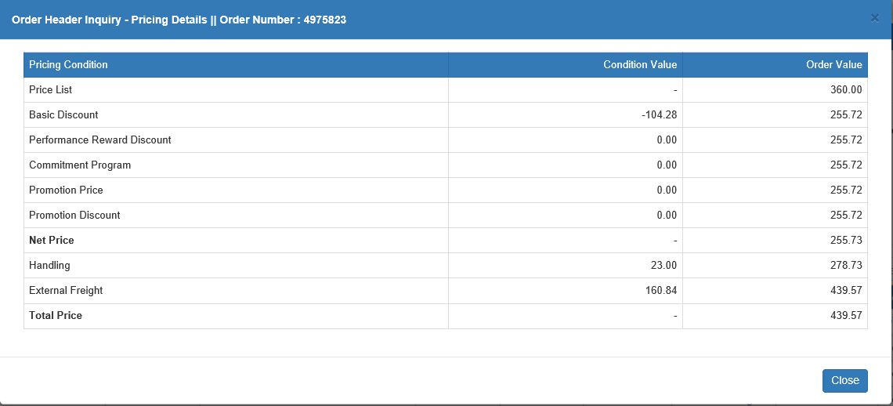

**Pricing Conditions:** This column shows the pricing conditions that could apply to the order (list price, discounts, promotions, etc.).

**Condition Value:** This column shows the dollar value of the condition.



Order Value:This column shows the calculation of the order’s net value when the condition values are applied. The **Total Price** line at the bottom shows the final net value after all conditions are applied.

Dealer: This column shows the dealer’s CNH country prefix and dealer code. In the case of a dealership with more than one code, it will show the code applied to that particular order.

Delivery Address:This column indicates whether the order will be delivered to the dealer’s default address (Dealer) or to a one-time shipping address (OTS). If the column shows OTS, you can click on the letters to view the address details:

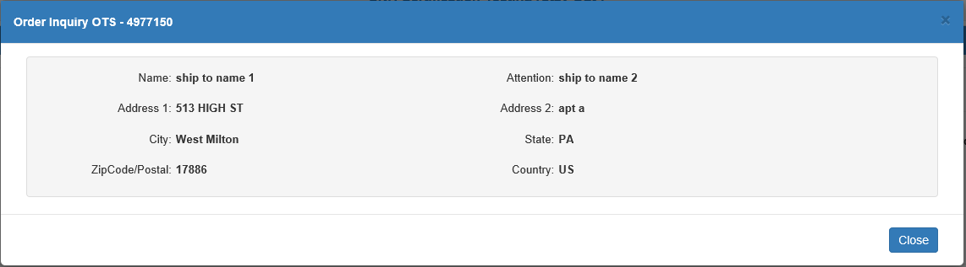

Service Level:This column indicates if there are service levels assigned to the order or not. If there are, the column will read “Service Levels” and clicking the words will show the Service Level details:

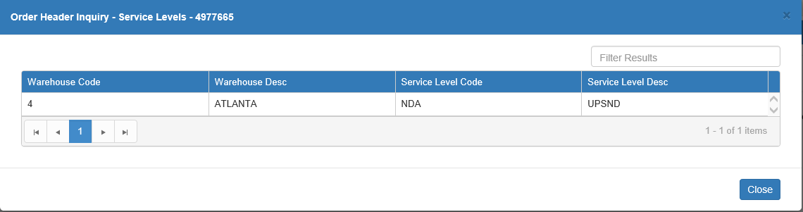

**Warehouse Code:** This column shows the code for the warehouse where the service level(s) apply.

**Warehouse Desc:** This column shows the warehouse’s description, typically it’s city of location.

**Service Level Code:** This column shows the service level code applied to the order.

**Service Level Desc:** This column shows the service level description.



Weight: This column shows the total weight of all parts on the order.

Print: Click the icon in this column to print a copy of the order details. The following window will appear:

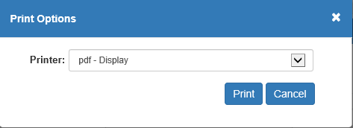

Choose a printer and click **Print** to receive the printout. Click **Cancel** to return to the main screen.

**Sample Order Printout**

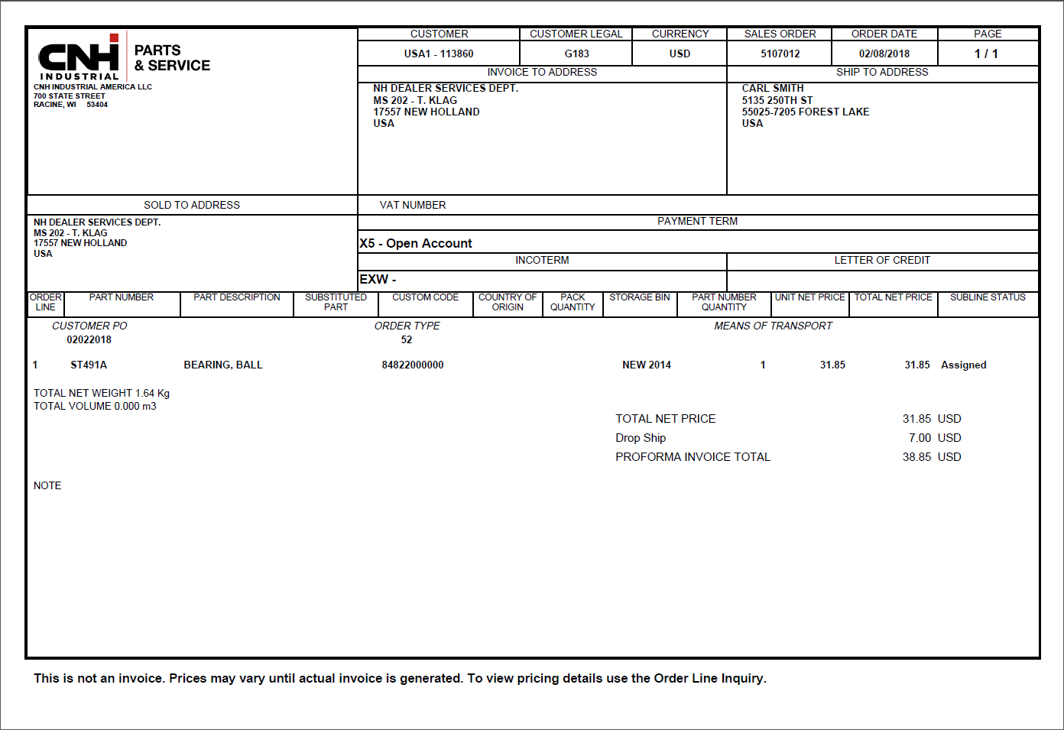



Expanded Column Headers: These columns only appear when the line is expanded. Collapsing the line will hide them again. They also **cannot** be used to sort the orders the same way the main grid headers can.

**Assigned Lines:** This column shows the number of lines that have had parts assigned to them by CNH for delivery.

**Assigned Line Amount:** This column shows the total dollar amount of the assigned lines.

**Assigned Line Weight:** This column shows the total weight of all parts on the assigned lines.

**Backorder Lines:** This column shows the number of lines on the order whose parts have been put on backorder by CNH.

**BO Line Amount:** This column shows the total dollar amount of the backordered lines.

**BO Line Weight:** This column shows the total weight of all parts on the backordered lines.

**Deferred Lines:** This column shows the number of lines on the order that were deferred by CNH. **NOTE:** U.S. and Canada dealers should never have values here, as all CNH orders in North America are immediate.

**Deferred Line Amount:** This column shows the total dollar amount of the deferred lines. **NOTE:** U.S. and Canada dealers should never have values here, as all CNH orders in North America are immediate.

**Wrong Lines:** This column shows the number of “wrong” lines, or lines in error, found on the order.